**QoP Survey App Specification**

Introduction:

[Intro of DnDLab and this research]

App Idea:

DnDLab is jointly launching a research project on Quality of Power Supply in Bangladesh. To get the data for this research we need to collect data. Load, complaint, and supply interruption data of two years from two substations and interruption data from four (depending on the availability) industrial customers located in Gazipur-1 and Mymensigh-2 will be collected and digitized. These data are recorded manually in a book and each day data is recorded in a page. Sample of data are given in figure 1,2,3 and 4.

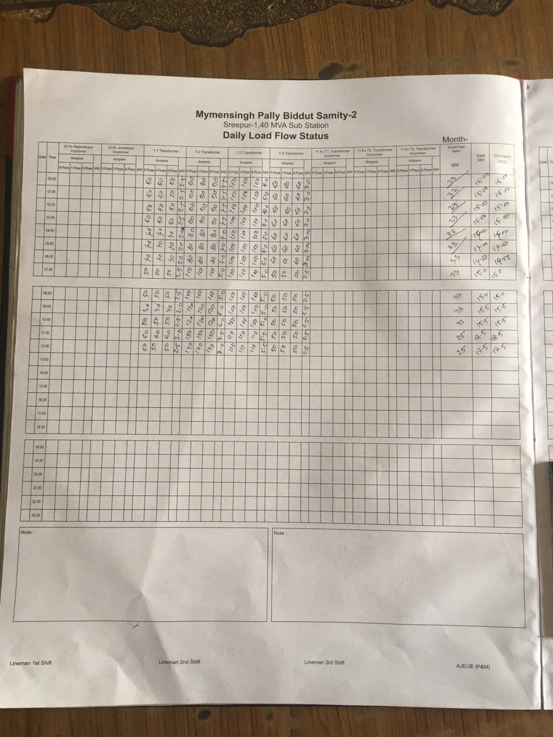

Figure 1 Load Data

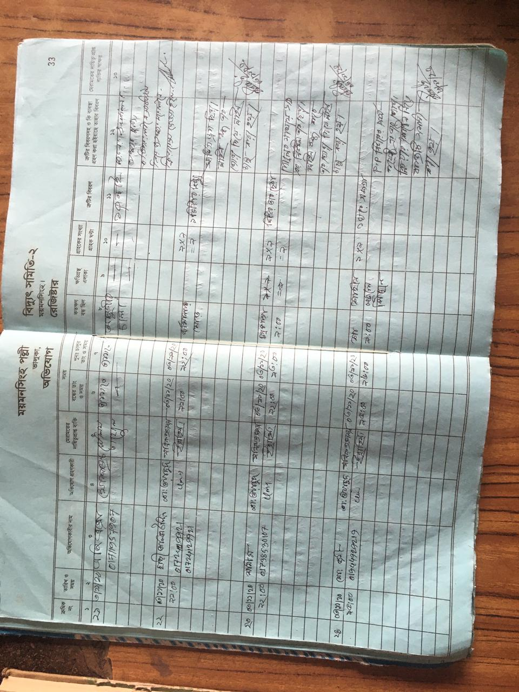

Figure 2 Complaint Data

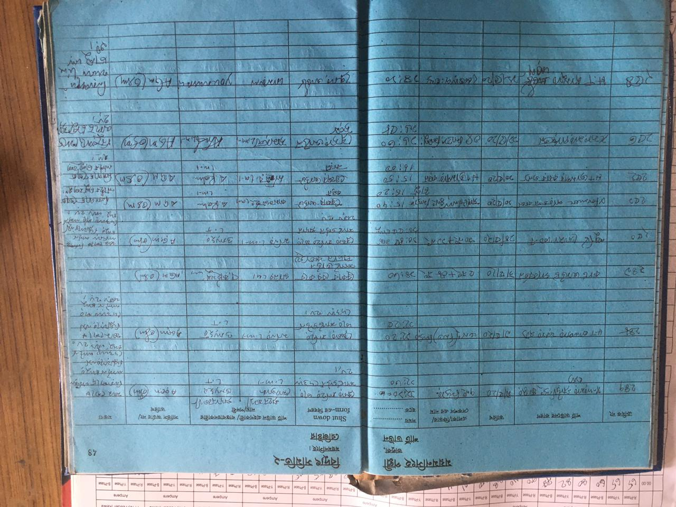

Figure 3 Shutdown Data

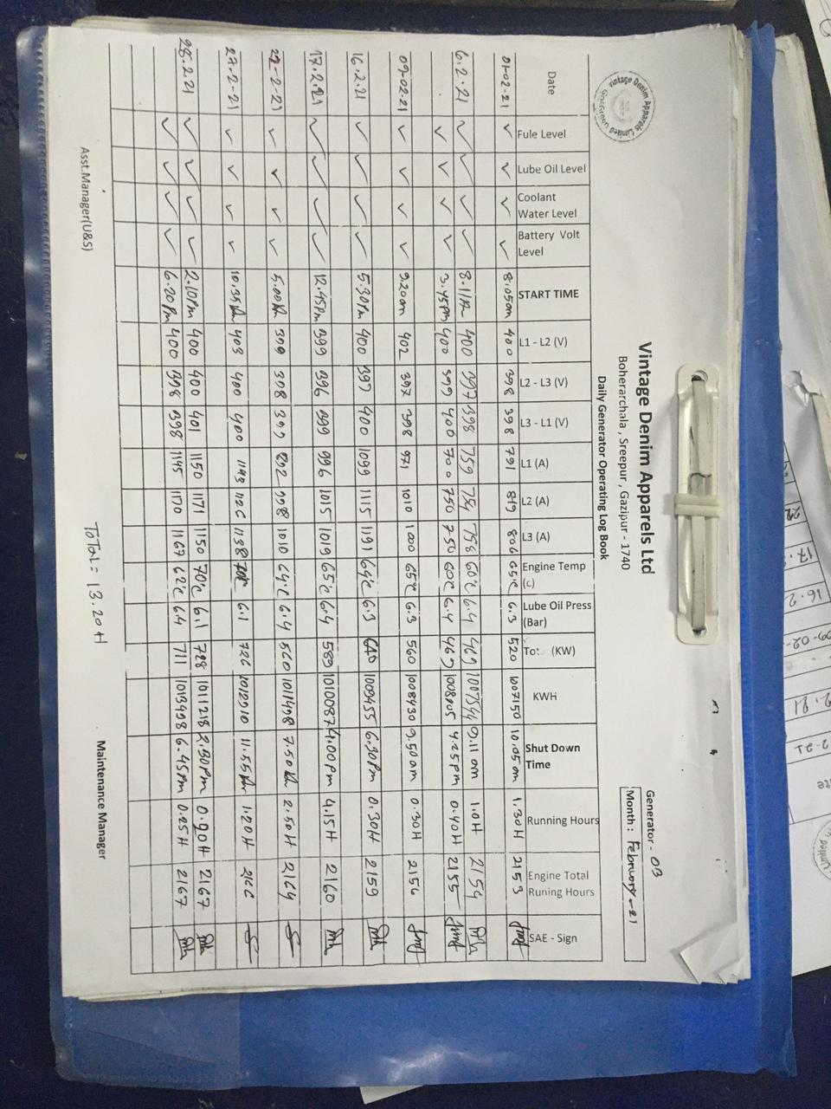

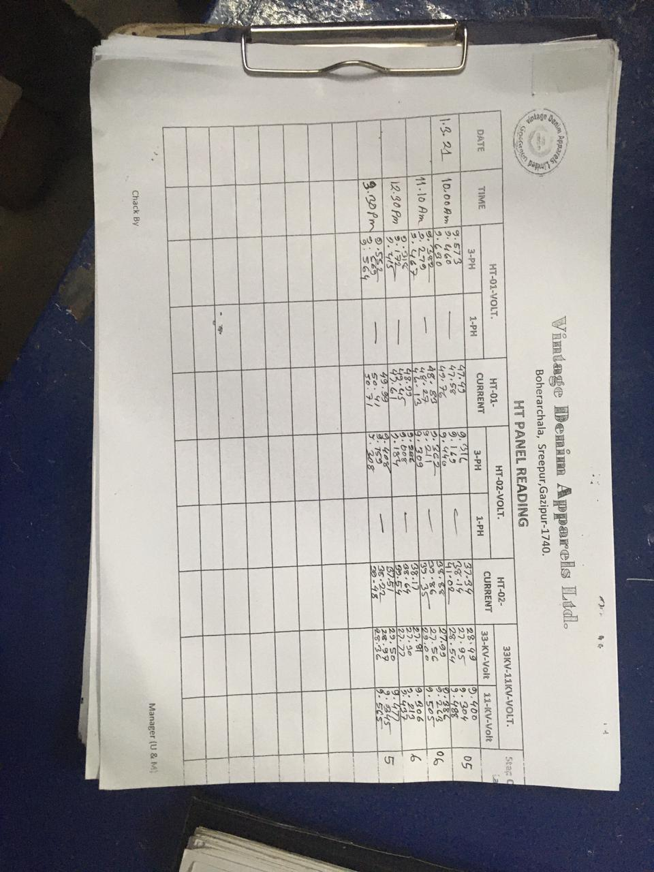

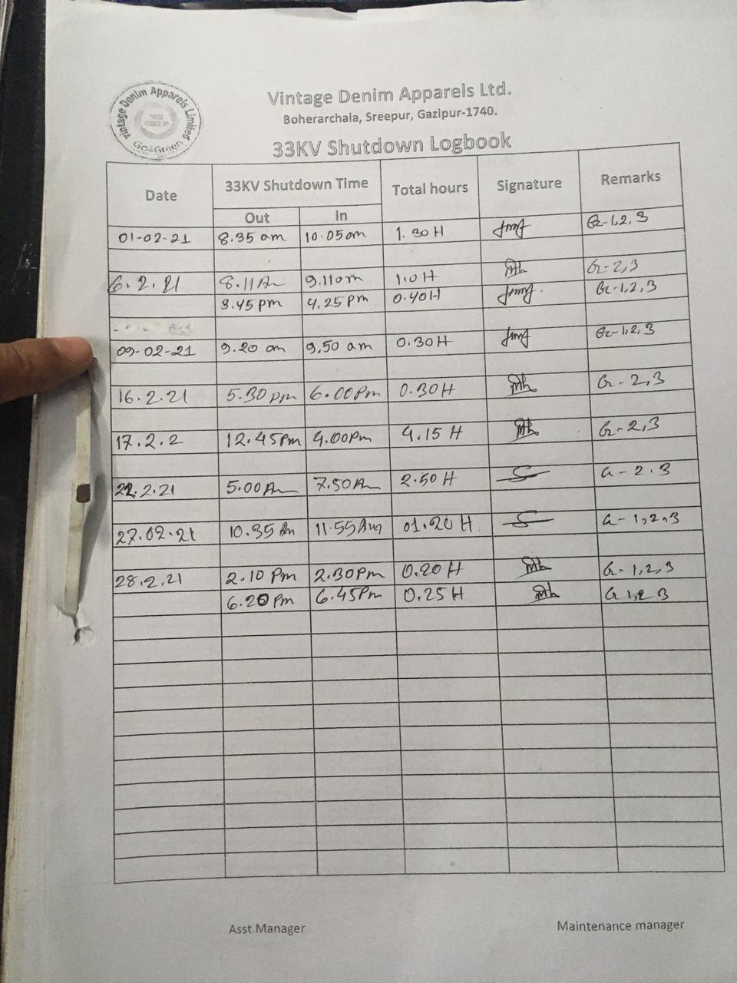

Figure 4 Interruption data from customer

This survey app will be used by the operators to take pictures of these books and store the images in tab storage with information of the operator, date, location etc. Later these images will be used to digitize the data. Operator will be manually entering the data from the image to the electricity data collection system using a PC. After that they need to verify if the entered data matches with the image data.

Target Audience:

The data entry operators are the target audience of this app. Again, supervisor will use this app for monitoring purpose.

Technology Stack & Platforms:

This app will be used in the regular smart phone and Tablet running Android operating system. Thus, we are targeting android platform primarily. We will also consider the cross-platform app with some popular tools like react native, PhoneGap etc. After getting the images, operators will enter the data in a web-based application.

Features:

The feature of this app is listed below,

1. User Registration: operators will register to the data entry system.
2. Login: use to login to the system
3. Data Image Collection: Operators will use this feature to take photos of manual data written in books.
4. Data Image Verification: Operators will use this page to verify if all data photos are taken.
5. Data Entry: Operators will use this feature to entry the data from the photo into the system
6. Data Entry Verification: This feature will be used to verify the entered/digitized data with the image. Operators can highlight/flag corrected or modified data to check and balance later.
7. Entry Summary Report: The summary report will help operators to know the progress of data entry works both individual and collective (for admin & management).
8. Admin Dashboard: Dashboard will help the admin and management to monitor the progress and take strategic decisions.
9. Supervisor Dashboard:
10. Data Collection Report (Admin): For monitoring purpose
11. Data Entry Report (Admin): For monitoring purpose

App Screen/Wireframe:

1. [Operator Registration page](operator_reg.html)
2. [Information required for data collection](data_collection_info.html)
3. [Data image collection page](data_image.html)
4. [Data image verification page](data_image_verification.html)
5. [Information required for data entry](data_entry_information.html)
6. [Substation daily load data entry page (incomer/transformer)](data_entry_load-1.html)
7. [Substation daily load data entry page (feeder)](data_entry_load-2.html)
8. [Substation complaints register page](data_entry_complaint.html)
9. [Substation shut down register page](data_entry_shutdown.html)
10. [Industry HT panel data page](data_entry_Industry-HT-Panel-Reading.html)
11. [Industry shut down register page](data_entry_industry-shutdown.html)
12. [Industry generator operating log data page](data_entry_industry-generator-log.html)

Timeline & Budget:

The app will be used in the first week of November. Thus, we have around 10 days to develop and test the app. Budget will be decided later.

Acceptance Criteria:

------------------------------------------------------

Photo image e timestamp

Laptop e supervisor will monitor and confirm the photo

MySQL/MongoDB

Output in CSV, JASON

Admin Dashboard